HOTEL RESERVATION

SYSTEM

TASK-2

1. ER DIAGRAM.

2. CLASS DIAGRAM.

3. DATABASE CREATION.

1. ER DIAGRAM:

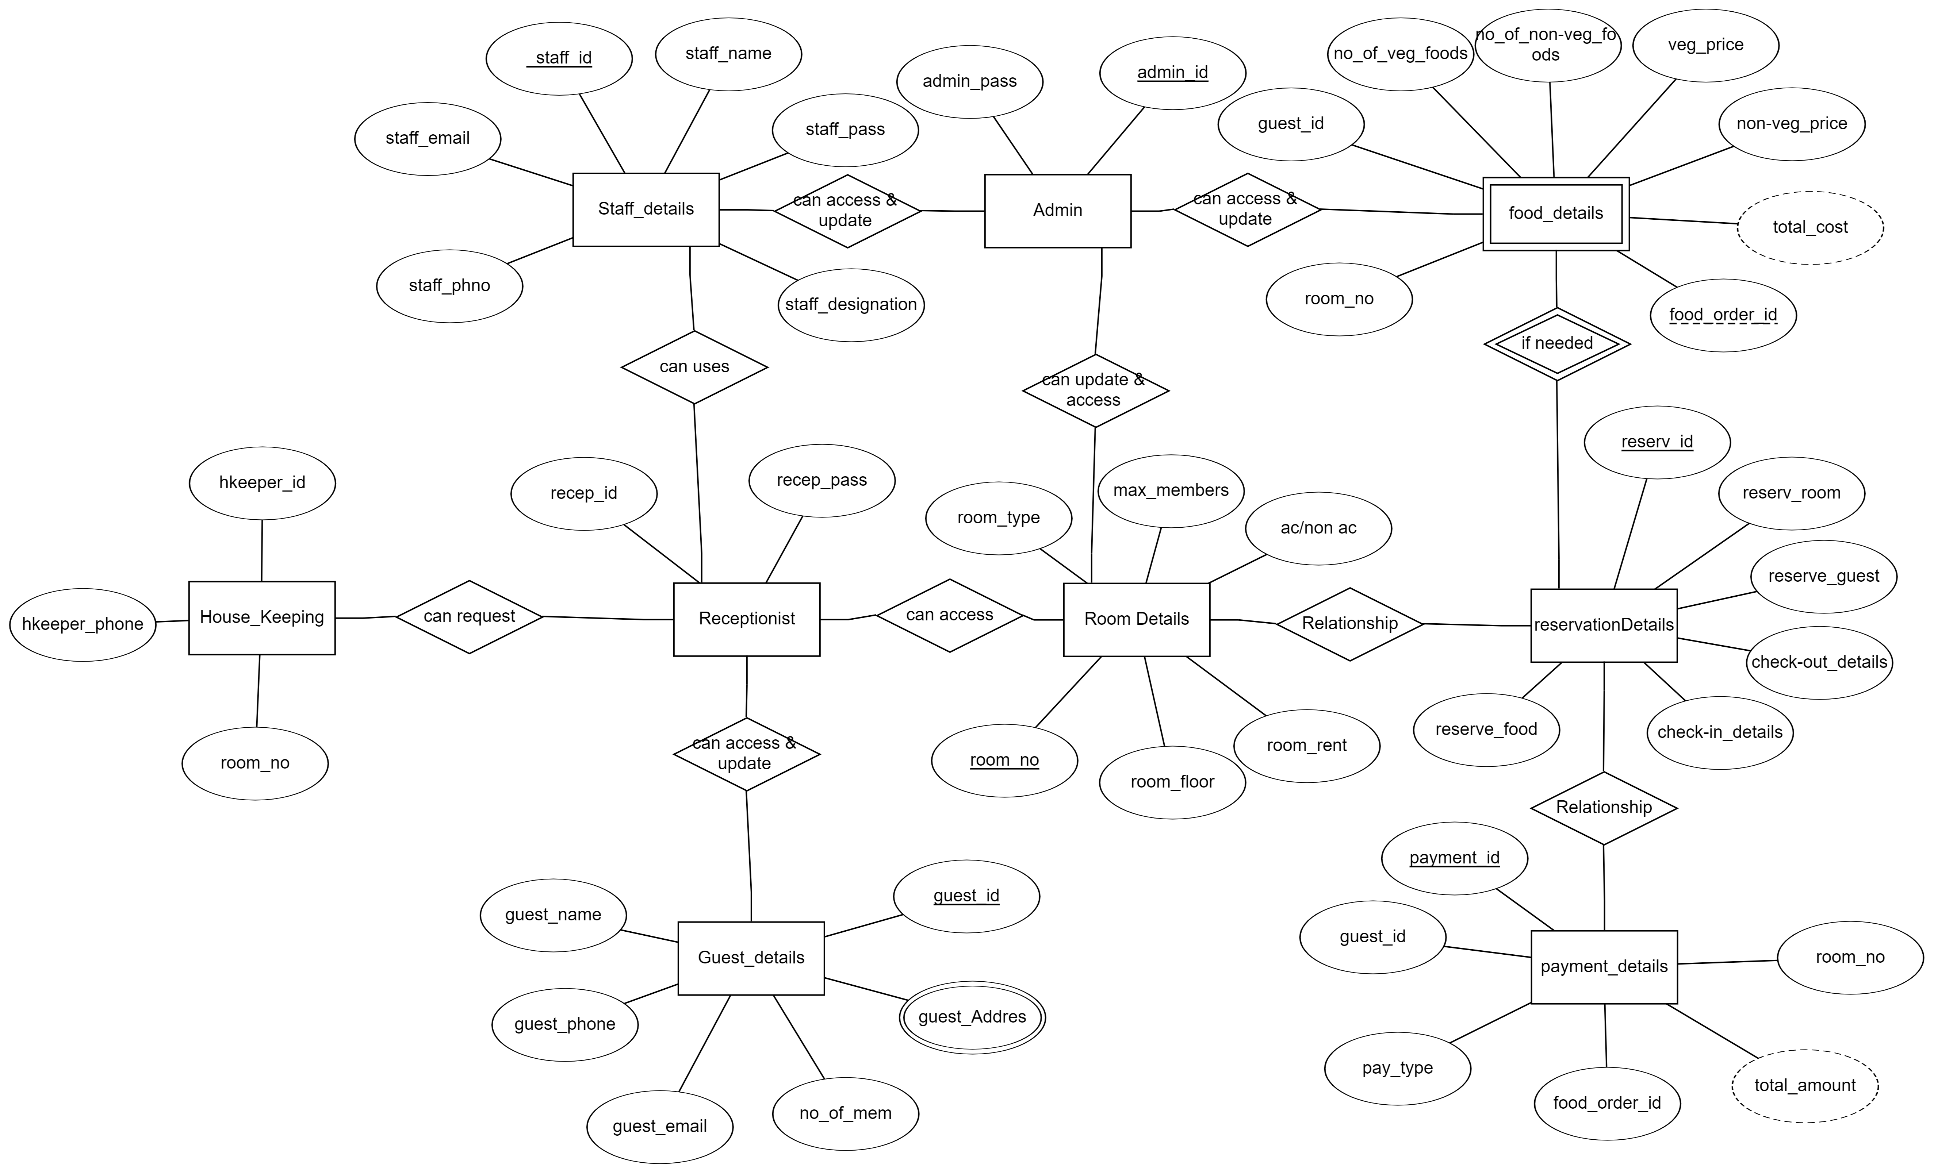

2.CLASS DIAGRAM:

